**Report on Information and Communication Technologies (ICT)**

Team 27 members:

* Slimani imad 232331397617
* Ait yahia Sarah MASSYLIA 232332138602
* Barkou abderrahmane 232331572705
* Kennouche Mouad 232331573213
* Admane abdelMalek 232331551111

Table of Contents: 

1. **Introduction.**
2. **Key Technologies in Information and Communications Technology (ICT)**
3. **Understanding Google Services and Their Role in Connectivity.**

* Gmail.
* Google drive
* Google Docs, Sheets, and Collaborative Platform.

1. **Embracing Microsoft Tools.**

* Office Suite (Word, Excel, PowerPoint).
* Microsoft teams.

1. **Navigating Git and GitHub.**

* Git
* Github
* Impact on Development Practices.

1. **Web Technologies**

* HTML and CSS.
* Evolutionary Trends
* Future Tech.

1. **Conclusion.**

**Introduction:**

Information and Communications Technology (ICT) is an expansive term encompassing the broader landscape of information technology (IT). This comprehensive concept emphasizes the fusion of telecommunications, including telephone lines and wireless signals, with computer systems. It goes beyond hardware and software, encapsulating essential enterprise tools such as middleware, storage solutions, and audiovisual components. The primary goal of ICT is to empower users by facilitating access, storage, transmission, comprehension, and manipulation of information.

At the core of ICT lies the aim to revolutionize how humans interact with data and information. It serves multifaceted objectives, striving to elevate human capabilities across diverse domains. One pivotal goal is to redefine and refine the way individuals generate, process, and disseminate information among themselves. Moreover, ICT endeavors to elevate proficiencies across various sectors, ranging from business, education, and medicine to real-world problem-solving. Beyond these pragmatic applications, it extends its influence to leisure activities, enriching experiences in sports, music, movies, and other recreational pursuits.

The seamless integration of telecommunications and computational systems, supported by sophisticated enterprise tools, forms the cornerstone of ICT. Through this integration, ICT aspires to transcend boundaries, unlocking new potentials and fostering advancements across a spectrum of human endeavors.

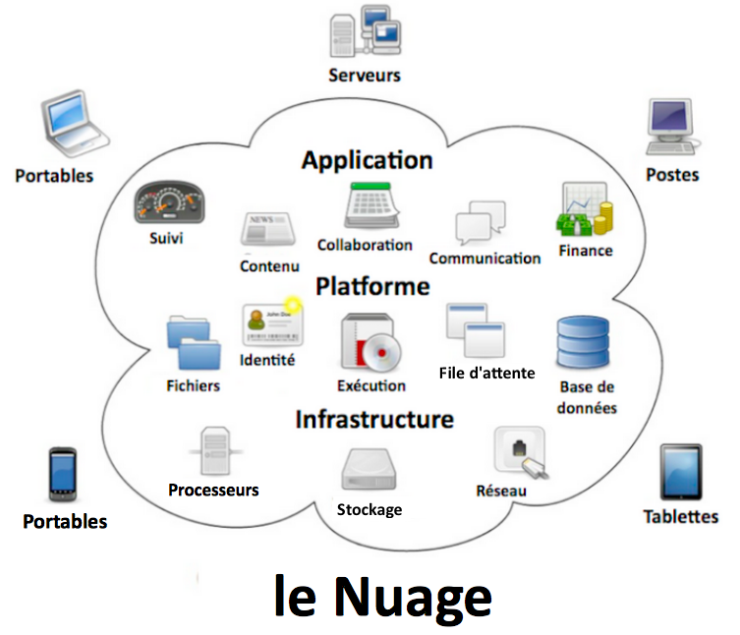

The following is a list of OCED countries by share of ICT sector in total value.

OECD: The organization for economic cooperation and development

| **Rank** | **Country** | **ICT sector in %** |
| --- | --- | --- |
| 1 | https://upload.wikimedia.org/wikipedia/commons/thumb/0/09/Flag_of_South_Korea.svg/23px-Flag_of_South_Korea.svg.png [South Korea](https://en.wikipedia.org/wiki/South_Korea) | 10.7 |
| 2 | https://upload.wikimedia.org/wikipedia/en/thumb/9/9e/Flag_of_Japan.svg/23px-Flag_of_Japan.svg.png [Japan](https://en.wikipedia.org/wiki/Japan" \o "Japan) | 7.02 |
| 3 | https://upload.wikimedia.org/wikipedia/commons/thumb/4/45/Flag_of_Ireland.svg/23px-Flag_of_Ireland.svg.png [Ireland](https://en.wikipedia.org/wiki/Republic_of_Ireland) | 6.99 |
| 4 | https://upload.wikimedia.org/wikipedia/en/thumb/4/4c/Flag_of_Sweden.svg/23px-Flag_of_Sweden.svg.png [Sweden](https://en.wikipedia.org/wiki/Sweden" \o "Sweden) | 6.82 |
| 5 | https://upload.wikimedia.org/wikipedia/commons/thumb/c/c1/Flag_of_Hungary.svg/23px-Flag_of_Hungary.svg.png [Hungary](https://en.wikipedia.org/wiki/Hungary" \o "Hungary) | 6.09 |
| 6 | https://upload.wikimedia.org/wikipedia/en/thumb/a/a4/Flag_of_the_United_States.svg/23px-Flag_of_the_United_States.svg.png [United States](https://en.wikipedia.org/wiki/United_States) | 5.89 |
| 7 | https://upload.wikimedia.org/wikipedia/en/thumb/4/41/Flag_of_India.svg/23px-Flag_of_India.svg.png [India](https://en.wikipedia.org/wiki/India" \o "India) | 5.87 |
| 8 | https://upload.wikimedia.org/wikipedia/commons/thumb/c/cb/Flag_of_the_Czech_Republic.svg/23px-Flag_of_the_Czech_Republic.svg.png [Czech Republic](https://en.wikipedia.org/wiki/Czech_Republic" \o "Czech Republic) | 5.74 |
| 9 | https://upload.wikimedia.org/wikipedia/commons/thumb/b/bc/Flag_of_Finland.svg/23px-Flag_of_Finland.svg.png [Finland](https://en.wikipedia.org/wiki/Finland" \o "Finland) | 5.60 |
| 10 | https://upload.wikimedia.org/wikipedia/en/thumb/a/ae/Flag_of_the_United_Kingdom.svg/23px-Flag_of_the_United_Kingdom.svg.png [United Kingdom](https://en.wikipedia.org/wiki/United_Kingdom) | 5.53 |
| 11 | https://upload.wikimedia.org/wikipedia/commons/thumb/8/8f/Flag_of_Estonia.svg/23px-Flag_of_Estonia.svg.png [Estonia](https://en.wikipedia.org/wiki/Estonia" \o "Estonia) | 5.33 |

**Key Technologies in Information and Communications Technology:**

Information and Communications Technology (ICT) encompasses a vast array of interconnected spheres, merging the internet-enabled domain with the mobility facilitated by wireless networks. Within this expansive framework, both time-honored technologies—such as landline telephones, radio, and television broadcast—and cutting-edge innovations, including artificial intelligence and robotics, coexist in widespread use.

Key components integral to ICT include the ubiquitous internet and its evolution, the emergence of the Internet of Things (IoT), the evolving concept of the metaverse, and the immersive realms of virtual reality. Additionally, social media platforms serve as pivotal elements within this sphere. Complementing these are integral services like cloud computing, video conferencing tools, collaborative platforms, and unified communications systems, each playing a vital role in enhancing connectivity and communication.

As the technological landscape continues to evolve, emerging innovations like 5G/6G networks, the conceptualization of Web3, and the potential of quantum computing contribute to the ever-expanding universe of ICT. Ultimately, any technology, infrastructure, component, or device fostering communication, facilitating data sharing, and fostering global connectivity—be it between individuals or between humans and machines—falls under the encompassing purview of ICT.

**Understanding Google Services and Their Role in Connectivity**



* **Gmail:** Electronic mail (email or e-mail) is a method of transmitting and receiving messages using electronic devices. It was conceived in the late–20th century as the digital version of, or counterpart to, mail (hence e- + mail). Email is a ubiquitous and very widely used communication medium; in current use, an email address is often treated as a basic and necessary part of many processes in business, commerce, government, education, entertainment, and other spheres of daily life in most countries.
* **Google drive:** Google Drive is a file storage and 

synchronization service developed by Google. Launched on April 24, 2012, Google Drive allows users to store files in the cloud (on Google's servers), synchronize files across devices, and share files. In addition to a web interface, Google Drive offers apps with offline capabilities for Windows and macOS computers, and Android and iOS smartphones and tablets. Google Drive encompasses Google Docs, Google Sheets, and Google Slides, which are a part of the Google Docs Editors office suite that permits collaborative editing of documents, spreadsheets, presentations, drawings, forms, and more. Files created and edited through the Google Docs suite are saved in Google Drive.

* **Google docs, google sheets and collaborative platforms:**

Google Docs:



Online Word Processor: Allows collaborative creation and editing of documents in real-time.

Multi-User Collaboration: Enables multiple users to work together simultaneously.

Cloud Storage: Documents are stored online, accessible from any device with an internet connection.

Google Sheets:

Online Spreadsheets: Used for data organization, calculations, and visualization.

Collaborative Environment: Supports multiple users editing and analyzing data concurrently.

Integration: Seamlessly integrates with other Google services like Drive for storage.

Collaborative Platforms:

Real-Time Collaboration: Tools such as Docs and Sheets enable simultaneous work.

Commenting and Revision History: Users can leave comments and track document changes.

Enhanced Teamwork: Facilitates smooth collaboration and communication among users.

**Embracing Microsoft Tools**

* **Office Suite (Word, Excel, PowerPoint):**

Microsoft's Office Suite—Word, Excel, and PowerPoint—significantly boosts productivity:

Word: Streamlines document creation and collaboration.

Excel: Empowers data management and analysis.

PowerPoint: Creates engaging and impactful presentations.

These tools optimize workflows, aiding document creation, data handling, and presentation delivery across various sectors.

* **Microsoft Teams:**

Microsoft Teams stands as an all-in-one collaborative platform, reshaping teamwork and communication within organizations. Its key features include:

Unified Communication: Integrates chat, video conferencing, and file sharing into a single interface, fostering seamless communication among team members.

Team Collaboration: Enables real-time collaboration on documents, projects, and tasks, allowing teams to work together efficiently and effectively.

Integration Capabilities: Seamlessly integrates with other Microsoft tools (such as Word, Excel, and PowerPoint) and third-party applications, streamlining workflow processes.

Remote Work Support: Facilitates remote work by providing a centralized hub for meetings, discussions, and file sharing, ensuring productivity regardless of location.

Microsoft Teams transforms the way teams collaborate, offering a centralized and versatile platform that enhances communication, teamwork, and overall productivity.



**Navigating Git and GitHub**

* **Git: **

Git is a distributed version control system that tracks changes in any set of computer files, usually used for coordinating work among programmers who are collaboratively developing source code during software development. Its goals include speed, data integrity, and support for distributed, non-linear workflows (thousands of parallel branches running on different computers)



* **Github:**

GitHub, Inc. is an AI-powered developer platform that allows developers to create, store, and manage their code. It uses Git software, providing the distributed version control of Git plus access control, bug tracking, software feature requests, task management, continuous integration, and wikis for every project.

* **Impact on Development Practices**

Git and GitHub have redefined development practices:

Efficient Collaboration: Facilitates seamless collaboration among developers worldwide, allowing shared code contributions, version control, and code review functionalities.

Streamlined Workflow: Enables a structured approach to coding, reducing conflicts, and enhancing team productivity through organized development processes.

Collaborative coding with Git and GitHub transforms development practices by fostering efficient collaboration and streamlined workflows among developers.



**Web Technologies**

* **HTML and CSS: **

HTML and CSS form the fundamental building blocks of web development:



HTML (Hypertext Markup Language): Serves as the backbone for structuring web content, utilizing tags to define elements and their relationships within a webpage.

CSS (Cascading Style Sheets): Complements HTML by providing styling and presentation options, enhancing the visual appeal and layout of web pages.

Web Content Design: HTML defines the content structure, while CSS determines the visual presentation, allowing for flexible and responsive web design.

HTML and CSS, as integral components of web development, work in tandem to create visually appealing and well-structured web content.

* **Evolutionary Trends:**

5G/6G Networks: Represent the next-generation cellular network technology, promising faster speeds, lower latency, and increased connectivity, revolutionizing communication and connectivity.

* **Future Tech:**

Web3: Envisions a decentralized internet, leveraging block chain technology for improved security, data ownership, and user control, potentially transforming online interactions and transactions.

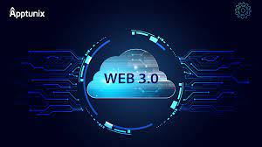

Quantum Computing: Offers unparalleled processing power, enabling complex computations at an unprecedented scale, with potential applications in cryptography, scientific research, and optimization problems.



**Conclusion:**

The exploration of Information and Communications Technology (ICT) and its diverse technological facets underscores the dynamic nature of our digital ecosystem. From Google's transformative services to the collaborative prowess of Microsoft Teams, Git, and GitHub, each innovation contributes significantly to modern connectivity and productivity.

HTML and CSS, as foundational web technologies, lay the groundwork for captivating online experiences, while evolutionary trends like 5G/6G networks and quantum computing promise paradigm shifts in connectivity and computational capabilities.

ICT's pervasive influence permeates sectors, enhancing business operations, educational methodologies, healthcare services, and entertainment experiences. As the technological horizon continues to expand, embracing these advancements presents boundless possibilities for innovation, global connectivity, and societal progress.

In this age of rapid technological evolution, leveraging these tools not only fosters efficiency but also empowers individuals and organizations to navigate the ever-evolving digital landscape, forging a future brimming with possibilities.

